What is payroll?

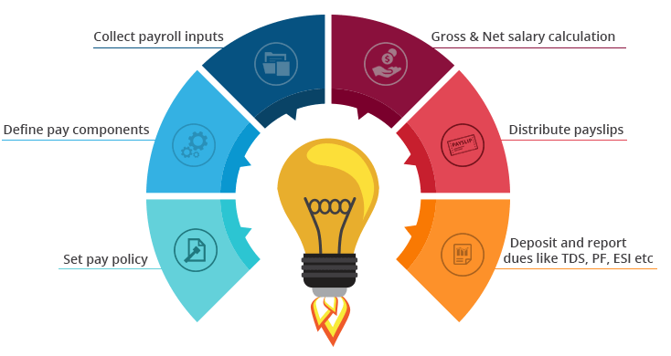

Payroll is a list of employees who get paid by the company. Payroll also refers to the total amount of money employer pays to the employees. As a business function, it involves:

Developing organization pay policy including flexible benefits, leave encashment policy, etc.

Defining pay slip components like basic, variable pay, HRA, and LTA

Gathering other payroll inputs (e.g., organization’s food vendor may supply information about the amount to be recovered from the employees for meals consumed)

The actual calculation of gross salary, statutory as well as non-statutory deductions, and arriving at the net pay

Releasing employee salary

Depositing dues like [TDS,](http://docs.greytip.in/display/GOIN/Tax+Deduction+at+Source) PF, etc. with appropriate authorities and filing returns

In short, we can say that payroll process involves arriving at what is due to the employees also called as ‘net pay’ after adjusting necessary taxes and other deductions.

|  |
| --- |
| The equation for calculating the net pay **Net pay** = Gross income - gross deduction  Where,  **Gross income or salary** = All types of regular income + allowances + any one-time payment or benefit  **Gross deduction** = All types of regular deductions + statutory deductions + any one-time deductions |

## What are the stages to processing payroll?

A payroll officer needs to do careful planning. There are always ongoing tasks that need attention and a constant need to monitor changes to withholdings, contribution to social security funds, etc. The entire process can be split into three stages, pre-payroll, actual payroll and post payroll activities.

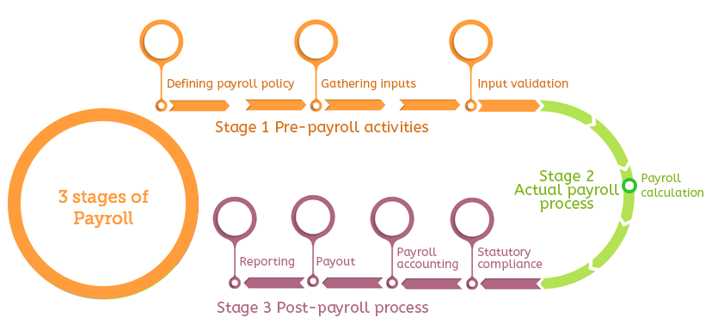

### Pre-payroll activities

#### Defining payroll policy

The net amount to be paid is affected by multiple factors. The company's various policies such as pay policy leave and benefits policy, attendance policy, etc. come into play at that time. As a first step, such policies need to be well defined and get approved by the management to ensure standard payroll processing.

#### Gathering inputs

Payroll process involves interacting with multiple departments and personnel. There can be information like mid-year salary revision data, attendance data, etc.

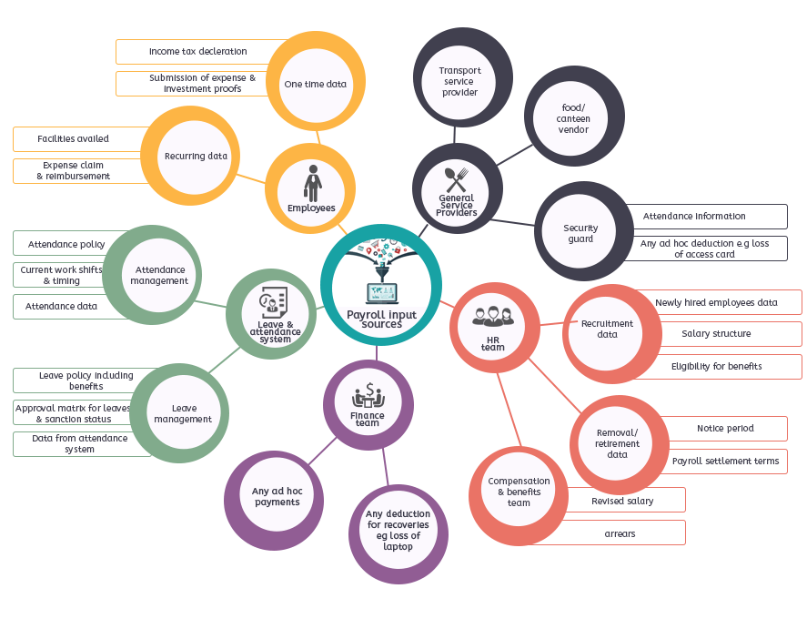

In smaller organizations, these inputs are received from a consolidated source or fewer teams. However, in a larger organization, the task of gathering data may look overwhelming. If you are using a smart payroll software having integrated features like leave and attendance management, employee self-service portal, etc. inputs collection process does not remain a problem.

#### Input validation

Once inputs are received, you need to check for validity of the data concerning adherence to company policy, authorization/approval matrix, right formats, etc. You also need to ensure that no active employee is missed out and that no inactive employee records are included for salary payment.

### Actual payroll process

#### Payroll calculation

At this stage, the validated input data is fed into the payroll system for actual payroll processing. The result is the net pay after adjusting necessary taxes and other deductions. Once payroll process is over, it is always a good practice to reconcile the values and verify for accuracy to avoid any errors.

### Post-payroll process

#### Statutory compliance

All statutory deductions like EPF, TDS, and ESI are deducted at the time of processing payroll. The company then remits the amount to the respective government agencies. The frequency can vary depending on the type of the dues. In most cases, payment of dues is made via challans. After all dues are paid return/report are filed. E.g., for filing PF return, ECR is generated and filed.

#### Payroll accounting

Every organization keeps a record of all its financial transactions. Salary paid is one of the significant operating costs which have to be reported in the books of accounts. As part of payroll management, it is essential to check that all salary and reimbursement data is fed accurately into accounting/ERP system.

#### Payout

You can pay salary by cash, cheque or bank transfer. Typically organizations provide employees with salary bank account. Once you complete payroll, you need to ensure that company’s bank account has sufficient funds to make the salary payment. Then you need to send a salary bank advice statement to the concerned branch. This statement is issued with particulars like employee id, bank account number, amount of wages, etc. If you are opting for payroll software that has employee self-service portal, you can easily publish the pay slips and employees can log-in to their account and access the pay slips.

#### Reporting

Once you complete payroll run for a particular month, finance and high management team may ask for reports such as department wise employee cost, location wise employee cost, etc. As a payroll officer, it becomes your responsibility to dig into the data and extract required information and share the reports.

### Statutory compliance in Indian payroll

When you run payroll, being statutory compliant means that you are paying as per the applicable employment norms set by the central and state legislation. The common statutory requirements that apply to Indian businesses include the provision for minimum wages, payment of overtime wages to workers, TDS deduction, contribution to social security schemes such as PF, ESI, etc.

While computing salary you need to consider all these deductions and contributions. Income tax is one such deduction. At the beginning of the year, the employee is asked to make a declaration about his additional incomes, tax saving investments, etc. called as ‘income tax declaration.’ Accordingly, employee’s tax liability is calculated, and TDS is deducted.

Let’s see how to calculate tax for any individual. In India, we have four tax brackets with an increasing tax rate.

|  |  |  |
| --- | --- | --- |
|  |  |  |
| **Income range** | **Tax rate** | **Tax amount** |
| Up to Rs.2,50,000 | NIL |  |
| Between Rs.2.5 lacs and Rs.5 lacs | 5% (Total income – 250000) + 4% cess |  |
| Between Rs.5 lacs and Rs.10 lacs | Rs. 12500 + 20% of (Total income – Rs. 500000) + 4% cess |  |
| Above 10 lacs | Rs. 112500 + 30% of (total income – Rs. 1000000) + 4% cess |  |

Based on above tax slabs, you can calculate monthly tax liability and deduct TDS. The TDS is then deposited monthly with the government, and a quarterly report of all deductions is also filed. Once you complete TDS returns for the fourth quarter, you can issue form 16 to employees. The employees use this form 16 as proof of tax deducted at the time of filing their individual income tax return.

Non-adherence with the statutory law can lead to hefty fines and penalties. That is why you need to be up to date on all tax and payroll statutory changes.

Let us understand how benefits and deductions affect payroll calculations.

### Considering TDS Deductions for Payroll Calculations

Every employer who is paying salary to employees has to make certain payroll deductions from the salary as TDS (Tax Deducted at Source) to meet [statutory compliance](https://empxtrack.com/blog/statutory-compliances-indian-payroll).

Employers need to deduct TDS under section 192 of the Income tax Act, 1961, if the salary is more than maximum amount exempt from tax. The employers also need to generate Form 24Q and Form 16 in a timely manner and submit these to the authorities. Some of the salary components that impact TDS deduction are**:-**

### Statutory Compliances for ESI Fund and PF Deduction

* [**ESI**](https://empxtrack.com/blog/esi-pf-statutory-compliance/)**C** fund, maintained by ESIC is applicable to employees’ earning Rs 15,000 or less per month to provide the cash and medical benefits to them and their families.

|  |  |  |
| --- | --- | --- |
| **ESIC contribution rates (Reduced w.e.f. 15/02/2019)** | | |
| Particulars | Current Rate | Reduced Rate |
| Employer Share | 4.75% | 4.00% |
| Employee Share | 1.75% | 1.00% |
| **Total** | **6.50%** | **5.00%** |

* **Provident Fund (PF)** is a compulsory contributory fund for the future of employees after their retirement or for their dependents in case of their early death. The **contribution** is 12% of PF Wages from both employee and employer. For the calculation, the maximum limit of Basic is Rs 6500/-. It means even if the employee’s PF Wages is above Rs 6500/-, the employer is liable to contribute only on Rs 6500/-, that is Rs 780/-.

However if an employee so desires he may voluntarily contribute more than 12%. Apart from it an employer also has to pay some administration charges.

The various accounts of PF Challan are as mentioned below.

|  |  |  |
| --- | --- | --- |
|  | **Employee** | **Employer** |
| A/c No 1: PF contribution Account | 12 | 3.67 |
| A/c No 2: PF Admin account |  | 1.10 |
| A/c No 10: EPS account |  | 8.33 |
| A/c No 21: EDLIS account |  | 0.50 |
| A/c No 22: EDLIS admin account |  | 0.01 |
| **Total** | **12** | **13.61** |

* **Professional Taxes** Professional tax or employment tax is a state-based tax. It is one of the statutory deductions from the gross income before computing the tax. can always opt for an upgraded plan that supports higher level of operations at any time. Since cloud solutions have data center at multiple locations, even during incidences of fire, flood, etc. your data remains safe.

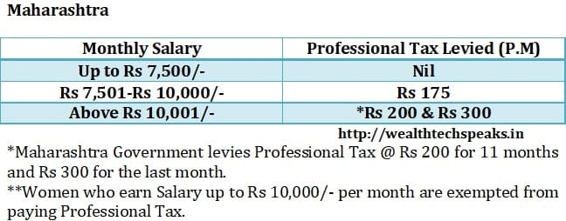

* **Gratuity** is the amount given to employees by employer when they leave the job after completing five years in service. Gratuity is calculated as Basic + DA divided by 26 * No of years of service *15.
* **HRA** – House Rent Allowance Exemption is possible based on the defined criterion, if expenditure on rent is actually incurred. HRA is taxable if residing in self-occupied house property. This allowance is applicable for exemption based on the location where the employee stays.
* **TRAVEL ALLOWANCE** – Tax free up to 800/-pm as per current rules.
* **LEAVE TRAVEL ALLOWANCE:** Exemption available only in respect of two journeys performed in a block of 4 calendar years.
* **CHILDREN EDUCATION ALLOWANCE** – Exempt up to Rs. 100 per month per child for a maximum of 2 children
* **MEDICAL ALLOWANCE** – Taxable (medical reimbursement is tax-free up to 15,000).
* **INVESTMENTS:** Investments in approved fixed deposit schemes, Equity oriented MF, PPF (Public Provident Funds), life insurance premiums, Company Provident Fund etc.
* under general payroll deductions u/s 80 C section can be made by salaried employees to avail the total tax benefit of Rs. 1,50,000/-.
* **12B:** Declaration of income from previous employer, other income, and commissions can be made on form 12B for proper TDS calculation for salaried employees.
* In addition there are other deductions too for taking care of parents, care of handicapped children, interest paid for housing loans that allow decrease in net salary payable to employees.

## Considering Employee Benefits for Payroll Calculations

* The employees of the company get many payroll benefits in addition to their regular salary. Most of the benefits that employees get impact tax calculations. Some such benefits are:
* **FLEXI ALLOWANCE BASKET:** The salary packages these days include a basket of flexible allowances to minimize the tax outgo. For example the employees can choose medical reimbursements and leave travel concession components that are exempt under limits prescribed by the Act.
* **PERQUISITES:** Perquisites are also the privileges given to employees by the employer over and above the regular income of the employees. It includes car conveyance, free food and beverages, interest free or concessional loan, sweeper/gardener/cook allowance, and leave travel concession etc. The perquisites are taxable but the tax on perquisites is generally borne by the employer and is tax exempt for the employee.

Section 80 Deduction Table

| **Section** | **Deduction on** | **Allowed Limit (maximum) FY 2018-19** |
| --- | --- | --- |
| 80C | Investment in PPF – Employee’s share of PF contribution – NSCs – Life Insurance Premium payment – Children’s Tuition Fee – Principal Repayment of home loan – Investment in Sukanya Samridhi Account – ULIPS – ELSS – Sum paid to purchase deferred annuity – Five year deposit scheme – Senior Citizens savings scheme – Subscription to notified securities/notified deposits scheme – Contribution to notified Pension Fund set up by Mutual Fund or UTI. – Subscription to Home Loan Account scheme of the National Housing Bank – Subscription to deposit scheme of a public sector or company engaged in providing housing finance | Rs. 1,50,000 |
|  | – Contribution to notified annuity Plan of LIC – Subscription to equity shares/ debentures of an approved eligible issue – Subscription to notified bonds of NABARD |  |
| 80D | Medical Insurance – Self, spouse, children Medical Insurance – Parents more than 60 years old or (from FY 2015-16) uninsured parents more than 80 years old | – Rs. 25,000 – Rs. 50,000 |
| 80DD | Medical treatment for handicapped dependent or payment to specified scheme for maintenance of handicapped dependent – Disability is 40% or more but less than 80% – Disability is 80% or more | – Rs. 75,000 – Rs. 1,25,000 |
| 80DDB | Medical Expenditure on Self or Dependent Relative for diseases specified in Rule 11DD – For less than 60 years old – For more than 60 years old | – Lower of Rs 40,000 or the amount actually paid – Lower of Rs 1,00,000 or the amount actually paid |
| 80U | Self-suffering from disability:  – An individual suffering from a physical disability (including blindness) or mental retardation. – An individual suffering from severe disability | – Rs. 75,000 – Rs. 1,25,000 |
| 80GGB | Contribution by companies to political parties | Amount contributed (not allowed if paid in cash) |
| 80GGC | Contribution by individuals to political parties | Amount contributed (not allowed if paid in cash) |
| 80RRB | Deductions on Income by way of Royalty of a Patent | Lower of Rs 3,00,000 or income received |
| 80CCC | For amount deposited in annuity plan of LIC or any other insurer for a pension from a fund referred to in Section 10(23AAB) | - |
| 80CCD(1) | Employee’s contribution to NPS account (maximum up to Rs 1,50,000) | - |
| 80CCD(2) | Employer’s contribution to NPS account | Maximum up to 10% of salary |
| 80CCD(1B) | Additional contribution to NPS | Rs. 50,000 |
| 80TTA(1) | Interest Income from Savings account | Maximum up to 10,000 |
| 80TTB | Exemption of interest from banks, post office, etc. Applicable only to senior citizens | Maximum up to 50,000 |
| 80GG | For rent paid when HRA is not received from employer | Least of : – Rent paid minus 10% of total income – Rs. 5000/- per month – 25% of total income |
| 80E | Interest on education loan | Interest paid for a period of 8 years |
| 80EE | Interest on home loan for first time home owners | Rs 50,000 |
| 80CCG | Rajiv Gandhi Equity Scheme for investments in Equities | Lower of – 50% of amount invested in equity shares; or – Rs 25,000 |

## Challenges in handling payroll management process

The payroll process becomes challenging due to two main reasons.

### The requirement to stay statutory complaint

As mentioned before, non-adherence to statutory laws can lead to levy of fines and penalties and in the worst case may even threaten the existence of the business. Today there are some advanced payroll management software that automatically processes payroll in compliance with statutory laws.

### Dependence on multiple payroll inputs sources

Before payroll can be processed, you need to get all the data together from sources such as attendance register, conveyance facility availed record, data from HR team like salary revision information, etc., making it a complicated process. For many years HR and payroll officers were managing payroll on excel sheets, but excel sheets have problems like dependency on excel formulas for salary calculation, complexity in adding and removing employees and other limitations like manual data entry, difficulty in extracting information, etc.

For many years HR and payroll officers were managing payroll on excel sheets, but excel sheets have problems like dependency on excel formulas for salary calculation, complexity in adding and removing employees and other limitations like manual data entry, difficulty in extracting information, etc.

## Various methods available to do payroll for your business

The possible options for running payroll can be

* Excel based payroll management
* Payroll outsourcing
* Using payroll software

### Excel based payroll management

Many businesses that are at an initial stage of operations and have a handful of employees usually go for excel based payroll management.

Excel based payroll management involves doing payroll calculation on excel sheets using standard payroll calculation template. The mathematical formulas are set that help the payroll officer do the computation. While this method does not involve any cost, but it has its inherent limitations like

* High chances of clerical and mathematical errors as data is entered manually
* Difficulty in adding and removing employees from payroll list
* Chances of duplicate data and omission of entries at times
* Need to monitor tax updates and other statutory changes like PF, PT etc

### Payroll outsourcing

Outsourcing payroll means you want an external agency to take care of your payroll function. Many organizations that do not have a dedicated person for payroll go for this option. Based on their pay cycle, every month they provide employee salary information and other data such as attendance, leaves, reimbursement details, etc. to the payroll service provider. The service provider then computes payroll and also takes care of statutory compliance. Since payroll is a crucial function and businesses want to have full transparency and control over it, they often hesitate in outsourcing payroll.

### Payroll software

As discussed above, for running successful payroll, you need to ensure that payroll inputs are coming from every source in a timely and seamless manner. The intent of using software is to reduce the friction in getting the inputs. There are advanced payroll management software available in the market that not only automates payroll computation but also serve as a holistic leave and attendance management, HR management and employee self-service portal. Depending on the size of your business and use cases you can opt for an appropriate payroll software for your business.

### Best Payroll software for your organization

The move from manual payroll system to automated one can save a lot of time. It not only helps in faster and accurate payroll processing but also keeps the employees, management and regulatory bodies happy.

There are some features that you should consider while selecting a payroll software.

### Ease of operation

Payroll function can be very cumbersome. You should opt for a system which has comprehensive but straightforward workflows. If the software is intuitive, it reduces the need for software training and guidance. Also, make sure that the software provider is providing well-updated documentation so that you can access the information anytime as you may need.

### Scalability

As organization size increases your software also need to serve you appropriately. The limitation can be in terms of employee’s data it process or in terms of the availability of features like leave and attendance management, reimbursement model, etc. The software offerings should be such that you can opt for advanced features at a reasonable price without much difficulty.

### Employee self-service module

One of the primary payroll input providers is the employee. He provides information such as income tax saving investment declaration, type of flexible benefit opted, etc. The interaction between the payroll officer and employee is usually very event-based. To understand the significance of [ESS module](https://www.greythr.com/employee-self-service-portal/) let’s assume a case of income tax declaration in two scenarios:

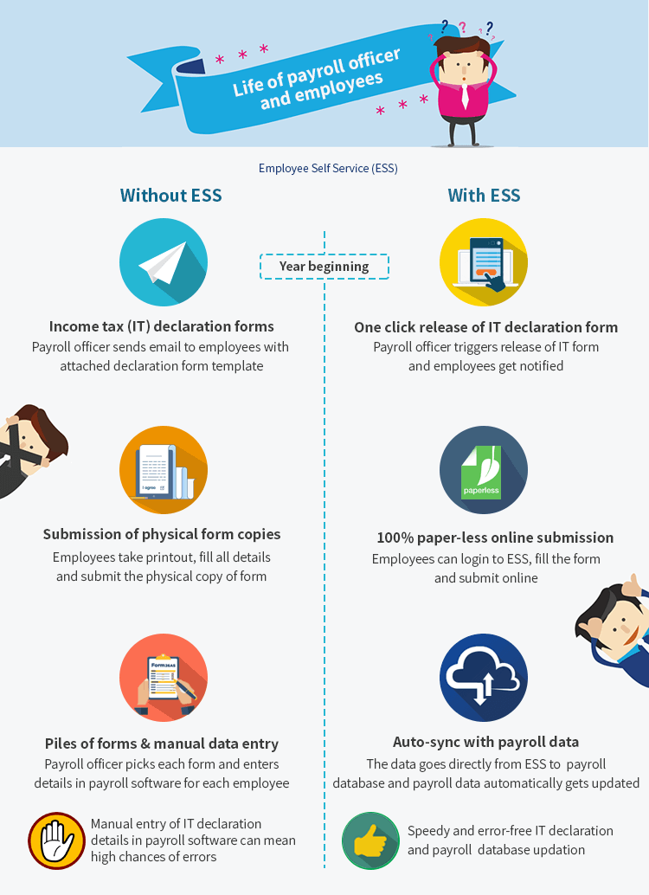

### Integration with time, attendance and leave management system

#### Time management

Typically this module is used to track time spent on projects or specific activities. Consulting firms such as audit firms, specialist doctors, etc., who manage critical projects require a robust time management module for tracking time and at times this data may also be used for billing clients.

#### Attendance

While most small organization go for manual attendance system, medium and large organizations have started using smart automated tools such as biometric method, auto-tracking via system log-in, access cards, iris capture, etc. The data is stored in a system and linked to the payroll software that uses this data to calculate attendance days, overtime, etc. For seamless payroll processing,

#### Leave management

In every organization, employees are entitled to take a certain number of leaves such as privilege or annual leave, casual leave, sick leave, holiday, etc.

If the software has leave management feature, HR can directly credit these leaves to the account of every eligible employee. As and when required, the employee can apply for leave through the system. A good system should also be able to define a workflow to notify the employee’s manager for either approval or rejection. Robust payroll software with built-in leave management feature can help attain accurate payroll.

### Integration with the accounting system

Your accounting/ERP system needs to record every financial transaction including payroll information like department wise employee cost, individual payroll components like reimbursements, tax due and paid, etc. Some payroll software has integration with accounting software via API (a way to push data directly from one software to another).

In the absence of such integration, the payroll officer needs to provide all transaction details to accounts department. The accountant then manually posts it in the form of journal entries in accounting/ERP software like Tally ERP, SAP, QuickBooks, etc. These integrations can help finance and payroll team work together and avoid any manual entry of data.

### Cloud-based software over on-premise solutions

The payroll management automation space is transforming rapidly. The on-premise software solutions have become obsolete and businesses are going for cloud-based solutions due to their advantages.

### Ability to access the data at any time and from anywhere

If you use cloud software, you do not need to be present in your office to be able to access your payroll data and employee data. You can login from anywhere at any time just like Gmail.

### The advantage over the inherent limitations of on-premise systems

The on-premise systems have their limitations like threat of data loss by fire, flood, etc. Also, the setup cost of these systems is huge and comes with an initial operation limit. Often the annual maintenance cost is quite high. Whereas, the cloud solutions are built on such technology, so you

|  |
| --- |
|  |

## Considering Statutory Requirements and Visa Rules for Expats in India for Payroll Calculations

Foreign nationals (except citizens of the countries of Nepal and Bhutan) require a valid passport or travel document and a valid visa to enter India. Expatriates are paid salaries several times than those of their Indian counterparts. Under India’s double-taxation agreements, salaries that a foreign company (and not its permanent establishment in India) pays for services rendered in India are taxable in India if the employee works for more than 182 days during the tax year.

A good [payroll software](https://empxtrack.com/hcm/payroll-software) can perform payroll calculations automatically and can take away the burden of managing correct payroll deductions and meeting statutory compliances for you.